**Ideation Phase**

**Define the Problem Statements**

|  |  |
| --- | --- |
| Date | 28 June 2025 |
| Team ID | LTVIP2025TMID54300 |
| Project Name | **ShopSmart** |
| Maximum Marks | 2 Marks |

**Customer Problem Statement Template:**

**Example:**

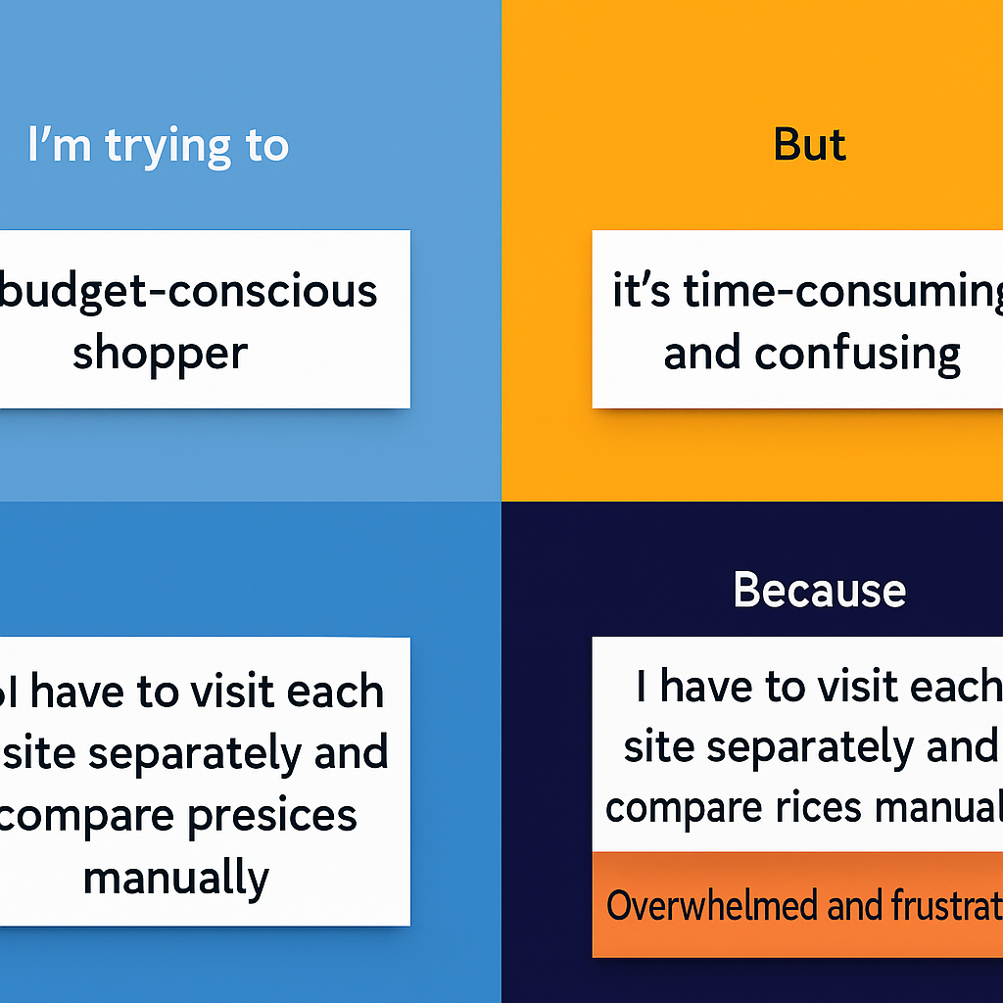

|  |  |  |  |  |  |
| --- | --- | --- | --- | --- | --- |
| **Problem Statement (PS)** | **I am (Customer)** | **I’m trying to** | **But** | **Because** | **Which makes me feel** |
| PS-1 | a busy working individual | buy groceries conveniently from home | I still have to visit physical stores and stand in queues. | there’s no reliable local grocery delivery platform | frustrated and tired. |
| PS-2 | |  | | --- | |  |  |  | | --- | | a regular grocery buyer | | ensure items I need are in stock before ordering | store inventory is not updated in real-time | shopkeepers manage stock manually. | disappointed and uncertain |
| PS-3 | a small grocery store owner | manage my inventory and orders digitally | everything is tracked on paper or Excel manually. | I don’t have access to a simple, digital solution | overwhelmed and inefficient |
| PS-4 | |  | | --- | |  |  |  | | --- | |  |   A digital-first user who prefers online apps | find a local grocery store that delivers quickly | most nearby stores don’t have an online presence | they haven't yet adopted digital commerce | forced to use big platforms or shop offline |